PUREFOUND

A report submitted in partial fulfilment of the requirements for the award of the degree of

BACHELOR OF TECHNOLOGY
in
COMPUTER SCIENCE AND ENGINEERING

By
ABHISHEK (IIITU18121)



SCHOOL OF ELECTRONICS/COMPUTING

INDIAN INSTITUTE OF INFORMATION TECHNOLOGY UNA
HIMACHAL PRADESH

JUNE 2021
BONAFIDE CERTIFICATE
This is to certify that the project titled PUREFOUND is a bonafide record of the work done by

ABHISHEK (IIITU18121)

in partial fulfilment of the requirements for the award of the degree of Bachelor of Technology in COMPUTER SCIENCE AND ENGINEERING of the INDIAN INSTITUTE OF INFORMATION TECHNOLOGY UNA, HIMACHAL PRADESH, during the year 2018 - 2022.

under the guidance of
Mrs PRANSHU (s)

Internship viva-voce held on: _________________

Examiner (Guide Name)

ORIGNALITY / NO PLAGARISM DECLARATION
I certify that this internship report is my original report and no part of it is copied from any published reports, papers, books, articles, etc. I certify that all the contents in this report are based on my personal findings and research and I have cited all the relevant sources which have been required in the preparation of this project report, whether they be books, articles, reports, lecture notes, and any other kind of document. I also certify that this report has not previously been submitted partially or as whole for the award of degree in any other university in India and/or abroad.
I hereby declare that, I am fully aware of what constitutes plagiarism and understand that if it is found at a later stage to contain any instance of plagiarism, my degree may be cancelled.

ABHISHEK(IIITU18121)

ABSTRACT
I am highly interested in Web and App Development. This project is solely based upon front-end development. I have been working with React in this project. React is a JavaScript library. I have created 2 designs, one for Web and one for App. Both the Web and App designs are based on e-commerce format. With this project, I could convert my theoritical knowledge to practicle knowledge and learnt some advanced techniques as well.

Keywords: Front-end, React

ACKNOWLEDGEMENT
I would like to thank the following people for their support and guidance without whom the completion of this internship in fruition would not be possible.
I would like to express my sincere gratitude and heartfelt thanks to Mrs Pranshu for the unflinching support and guidance, valuable suggestions and expert advice. Her words of wisdom and expertise in subject matter were of immense help throughout the duration of this project.
I also take the opportunity to thank our Director and all the faculty of School of Computing/Electronics, IIIT Una for helping me by providing necessary knowledge base and resources.
I would also like to thank my parents and friends for their constant support.

ABHISHEK (IIITU18121)

TABLE OF CONTENTS
Title Page No.
ABSTRACT iii
ACKNOWLEGEMENT iv
TABLE OF CONTENTS v
LIST OF ACRONYMS vi
LIST OF TABLES vii
LIST OF FIGURES viii

1 Introduction 1
1.1 Why React? 1
1.1.1 Technical Aspects 1

2 Review of Literature 2
2.1 Section title 2
2.1.1 Subsection title 2

References 3

Appendices 3

LIST OF ACRONYMS
ABC Artificial bees algorithm
GA Genetic algorithm

LIST OF TABLES
2.1 Table title 1
2.2 Table title 10

LIST OF FIGURES
2.1 Figure caption 1
2.2 Figure caption 10

Chapter 1
Introduction

  - Why React?
React is perhaps the most popular front-end JavaScript library in today’s times. It's used for handling the view layer for web and mobile apps. React also allows us to create reusable UI components. React allows developers to create large web applications that can change data, without reloading the page. The main purpose of React is to be fast, scalable, and simple From startups to big enterprises and corporations, React is finding phenomenal applications in many of these organizations. Leading and popular companies like Airbnb, Netflix, The New York Times are using this highly-useful technology on their websites, and their mobile applications.
    - Technical Aspects
Web Design
React Components: A React component is in essence, a piece of the user interface - splitting the user interface into reusable and independent parts, each of which can be processed separately. These are of 2 types – Functional components and Class components.
I mostly used Functional components as a functional component is just a plain JavaScript function which accepts props as an argument and returns a React component.

Hooks: In this project, I have implemented useState and useReducer for state management. As the replacement of lifecycle methods, I used useEffect to achieve side-effects.

Data-Fetching: I have fetched emails of 500 users from JSONPlaceholder(Free Fake Rest API) and stored them using hooks.

React-Router: It is the standard Routing library for React. It keeps your UI in syn with the URL. Where you need basic navigation, it prevents reloading of the page.

SignUp and Login form validation: Created basic form validation using ‘yup’ library. Compared the fetched user emails to generate errors like “Email already taken” and “Email doesn’t exist”.
App Design
React Native: It is a mobile framework that compiles to native app components, allowing you to build native mobile applications for different platforms (iOS, Android and Windows Mobile) in JavaScript that allows you to use ReactJS to build your components, and implements ReactJS under the hood. Native APIs are used to render components in mobile.

Expo CLI: Expo Command Line Interface is the main interface between a developer and Expo tools.

Chapter 2
Review of Literature

2.1 Section title
Lorem ipsum dolor sit amet, consectetur adipiscing elit, sed do eiusmod tempor incididunt ut labore et dolore magna aliqua. Ut enim ad minim veniam, quis nostrud exercitation ullamco laboris nisi ut aliquip ex ea commodo consequat. Duis aute irure dolor in reprehenderit in voluptate velit esse cillum dolore eu fugiat nulla pariatur. Ex-cepteur sint occaecat cupidatat non proident, sunt in culpa qui officia deserunt mollit anim id est.
2.1.1 Images
The images have to referred in the text as Fig. 2.1. For example, Fig. 2.1 shows the sample circuit.
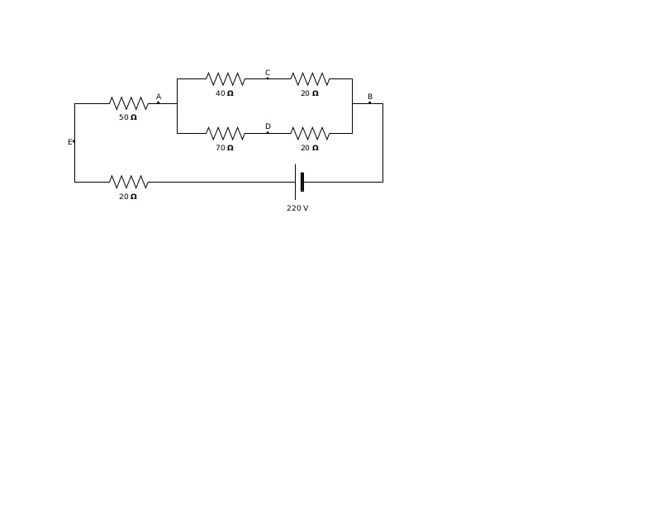
Figure 2.1: Circuit for the example network.
Lorem ipsum dolor sit amet, consectetur adipiscing elit, sed do eiusmod tempor incididunt ut labore et dolore magna aliqua. Ut enim ad minim veniam, quis nostrud exercitation ullamco laboris nisi ut aliquip ex ea commodo consequat. Duis aute irure dolor in reprehenderit in voluptate velit esse cillum dolore eu fugiat nulla pariatur. Ex-cepteur sint occaecat cupidatat non proident, sunt in culpa qui officia deserunt mollit anim id est laborum.
2.1.2 Images and Tables
The tables have to referred in the text as Table. 2.1. For example, Table. 2.1 shows the sample table.
Table 2.1: Table caption …
Algorithm | Item 1 | Item 2 | Item 3
Algorithm 1 | 1 | 3 | 4
Algorithm 2 | 2 | 3 | 2
Algorithm 3 | 3 | 2 | 1

References

- G. Eason, B. Noble, and I. N. Sneddon, “On certain integrals of Lipschitz-Hankel type involving products of Bessel functions,” Phil. Trans. Roy. Soc. London, vol. A247, pp. 529–551, April 1955.
- J. Clerk Maxwell, A Treatise on Electricity and Magnetism, 3rd ed., vol. 2. Oxford: Clarendon, 1892, pp.68–73.
- I. S. Jacobs and C. P. Bean, “Fine particles, thin films and exchange anisotropy,” in Magnetism, vol. III, G. T. Rado and H. Suhl, Eds. New York: Academic, 1963, pp. 271–350.
- K. Elissa, “Title of paper if known,” unpublished.
- R. Nicole, “Title of paper with only first word capitalized,” J. Name Stand. Abbrev., in press.
- Y. Yorozu, M. Hirano, K. Oka, and Y. Tagawa, “Electron spectroscopy studies on magneto-optical media and plastic substrate interface,” IEEE Transl. J. Magn. Japan, vol. 2, pp. 740–741, August 1987 [Digests 9th Annual Conf. Magnetics Japan, p. 301, 1982].
- M. Young, The Technical Writer’s Handbook. Mill Valley, CA: University Science, 1989.

Appendices

Appendix A
Code Attachments
The following is the partial / subset of the code. Code of some module(s) have been wilfully supressed.
A.1 Sample Code
#include <iostream>
using namespace std;
int main()
{
cout << "Hello, World!";
return 0;
}

